**CPSC 531-01 Advanced RDBMS**

**Final Group Project Report**

**Joe’s Chop**

**By: Group DB-8**

**Hsu Shih Li Student ID: 887463198**

**Nidhi Shah Student ID: 887446938**

**CPSC 531-01 (13606)**

**Spring, 2021**

**Professor: Dr. Chun-l Phillip Chen**

**Department of Computer Science**

**California State University, Fullerton**

**May 18, 2021**

**Table Of Contents**

**Abstract** **4**

**Chapter 1: Introduction** **4**

1.1 Background: 4

1.2 Project Goal and benefits of this project 5

1.3 Relevance and Significance 5

1.4 Assumption and limitation: 6

**Chapter 2: Project Requirements** **7**

2.1 Data Requirements: 7

2.2 Function Requirements: 11

2.2.1 Implement a new customization plan 11

2.2.2 customization plan progress processing 12

2.2.3 Joe’s Chop employee Workload Management 14

2.2.4 Manage employee relation with Joe’s Chop 15

2.2.5 Monitoring vehicle customization progress 16

2.2.6 personal profile summary and modification 16

**Chapter 3: Methodology** **17**

3.1 Data Model 17

3.1.1 Conceptual Model (ER-MODEL) 17

3.1.2 Logical Data Model (In Normalized form) 18

3.2 System Architecture with tools and techniques 21

3.4 DDL statement summary 21

3.5 Function requirement Design 22

3.5.1 Implement a new customization plan 23

3.5.2 customization plan progress processing 26

3.5.3 Joe’s Chop employee relation with Joe's Chop 29

3.5.4 Manage employee relation with Joe's Chop 32

3.5.5 Monitoring vehicle customization progress 35

3.5.6 personal profile summary and modification 37

3.6 System installation and implementation 39

3.6.1 What do you need to run the application? 39

3.6.2 User-guide 39

**Chapter 4: Result and Discussion** **39**

**Chapter 5: Conclusion** **41**

5.1 Significance of the project: 41

5.2 Lesson Learned: 41

5.3 Future design improvement: 41

5.4 Potential Use: 42

**Reference** **42**

**Appendices** **42**

**Table of Figures**

FIG.1. ER-MODEL for Joe’s Chop **19**

FIG.2. Logical Data Model for Joe’s Chop (3rd normalized form) **20**

FIG.3. Joe’s Chop system architecture **2**1

FIG.4. Joe’s Chop Customization plan Creation Form **2**4

FIG.5. Joe’s Chop Customization progress report and form **2**8

FIG.6. Joe’s Chop Employee management report **3**1

FIG.7. Joe’s Chop Customization plan report for Customer View **3**6

# Abstract

Modifying the vehicle has become a trend in the automotive business today. Joe's Chop Shop is one of the most well-known auto modification companies, owned and operated by Joe, who is interested in increasing business by incorporating new marketing tactics as a web application. However, for Joe to be able to run the web application system and understand the business growth, he also requires a support system to store and manage all the required data. The DB-8 team proposes this project to support Joe's dream by providing a well structured SQL based RDBMS support with an easy-to-use web application with required functionality.

DB-8 team is using AWS platform to develop a relational database for the Joe's chop customization project using AWS RDS service. Therefore, despite the growth of Joe's chop company, he didn't have to spend money managing a large amount of data because of the AWS platform. The relational database being prepared by the DB-8 team is normalized until the third normalization form in order to reduce redundancy and increase efficiency. DB-8 development is also evaluating the future of this project in regards to supporting unstructured data as images for a complete customization progress report by including AWS S3 bucket support with AWS EC2 service.

Joe's project for customization has begun by the DB-8 team in providing the online forms for customization plan creation, modification, and also by providing the report for it to help the customer see the progress of the modification. Moreover, we propose to manage employee relations functions for Joe's Chop company's Human Resource Department to ensure its strong employment growth. In this document, the requirements are outlined, database design is explained, functionality is specified for the Joe's Chop business and future development of this project is explicitly listed.

# Chapter 1: Introduction

## 1.1 Background:

The small garage known as Joe's Chop is well-known for its vehicle customizations in the region and nationwide. The vision of Joe's Chop is to give customers a unique drive so they can enjoy an adventurous drive for a price a little bit higher than ordinary. Customers are categorized as either the kind that allows Joe to customize any way he wants or the group which carefully works out the amount of money spent per modification.

As Joe's business grows, he will not have the time to sit down with customers and discuss and share decisions. The second issue is his dislike for the paperwork, which is the key to making enough profit. The paperwork includes documenting expenses and pricing. To show the customer what they can choose from with an initial customized plan allowing them to discuss and decide, Joe needs to have a website. Using the website, his company can share the daily progress of the customized product as well as the final expenses with his customers.

In order to increase the profitability of Joe's business with the website application and to give the increasing number of customers the support they need, we are proposing this relational database management system. It will provide information for his employees to prepare the report, such as an initial customization plan, and analyzing the customer's final bill. The customers can gain insight and feel connected to the vehicle's entire customization process with daily data updates, such as estimated time and cost for customization processes, employee details, modification list and final bill.

## 1.2 Project Goal and benefits of this project

The objectives of this project are to generate a web-based application that works in conjunction with a relational database in the background in order to increase efficiency and profit at the customization shop named Joe’ Chop. The Joe's chop team can use this web app to share the customization plan in detail with their customers showing progress information including final-fee information and customers can access this information online through this application. This will increase the communication between the staff and customers, which is of paramount importance for the growing business.

**Aim for this project**: First DB-8 team members will build the relational database using the requirements gathered from the description from the document. Following the development of the database, team members will implement the web application that connects to that database, so users can use that for running their business. Users will use data stored in databases to illustrate how vehicles are customized to suit specific clients' needs and can update the information accordingly.

## **1.3** **Relevance and Significance**

The **relevance of databases** means the ability to retrieve the material that satisfies the user's need. The employee's need of generating and further updating customized reports with their customers' details within their vehicle conditions have been satisfied with our relational database named JoeDB. Additionally, the customer’s need to have access to updated customization information and the final bill in the report is also satisfied by our project. The management of Joe’s chop shop has access to all employee data and can see reports on customization progress that each employee is responsible for. Additionally, Joe’s Chop’s management team also made use of this tool when terminating or firing employees.

The database design is a blueprint or well-designed document that describes the storage, retrieval, and manipulation of data for the web application to function with the relevant data with a satisfactory implementation. It is imperative that a database designed with DBMS be effective enough to support any type of query accurately, and does not have any data redundancy.

**Significance of JoeDB database Design:**

1. **Consistency:** JoeDB’s database design incorporates all data that is relevant and necessary for Joe’s chop web application.
2. **Cascading:** JoeDB keeps parent tables and child tables related to each other through a foreign key with cascade allowance. Those relationships ensure that data entry in child tables is related to foreign key data in parent tables. This will prevent data repetition.
3. **Redundancy:** The data model in JoeDB has been normalized from 1NF to 3NF in order to reduce redundancy.
4. **Maintenance:** The JoeDB database has been designed so that maintaining it does not pose so many challenges.

## 1.4 Assumption and limitation:

**The assumption behind the JoeDB database Design:**

We are looking for the following entities to help our customer Joe’s Chop with a new service requirement that will enable them to enhance customer experience through a web application. In addition, the following list allows us to see the relationship between those entities.

1. One customer can have many vehicles that are under a customization plan in Joe’s Chop Shop.
2. One vehicle can have many customization plans that differ from each other according to the date of customization done.
3. In one customization plan, there could be many tasks to complete by different employees. The summation of estimation prices and final amounts of each task determines the estimated price and the final bill of the customization plan.
4. However, for each customization plan, only one employee is responsible to represent each detail of customization to related customers.
5. An employee of Joe's Chop develops an estimation price of each customization plan according to the parts needed and labor required to finish each task (item) within that plan.
6. For that, the Part and Labor entity must be used, which includes all the available parts and related labor task details as well as their cost.

**Limitation behind the JoeDb database Design:**

According to Joe's Chop requirement, they would like to show the day-to-day progress of their customization work to customers through the use of images. Nevertheless, the relational database we are building has limitations regarding the handling of images in the tables.

We anticipate Joe’s Chop’s number of customers won’t be as high as big data, so we are designing a relational database for their application. However, as the data age gets larger then the handling of it becomes more challenging due to the inability to scale vertically. Further, in order to create the solution to them, we will require more storage, more resources and may need to redesign the database with indexes.

# Chapter 2: Project Requirements

## 2.1 Data Requirements:

In the following screen, we collect all the data requirements for the database design and attempt to group the data into entities and attributes.

1. **Entity definition (Customer)**

**Customer ID**: each customer has a unique ID to recognize different customers.

**Customer_Name**: contain the customer’s first and last name.

**Cust_Phone**: contain the customer phone number to have a better discussion when needed.

**Cust_Email**: contain the customer email to have a better discussion when needed.

Address, City, State, Zip: contain the address of the customer.

**Customer: Customer_ID, Cusomter_Name, Cust_Phone, Cust_Email, Address, City, State, Zip.**

|  |  |  |  |  |  |  |  |
| --- | --- | --- | --- | --- | --- | --- | --- |
| **Customer_ID** | **Cusotmer_Name** | **Cust_Phone** | **Cust_Email** | **Address** | **City** | **State** | **Zip** |
|  |  |  |  |  |  |  |  |

1. **Entity definition (Employee)**

**Employee ID**: each employee has a unique ID to recognize Employee details.

**Name**: Employee also identifies with first and last name.

**Title**: Each employee has a title among Joe’s Chop association and management.

**Phone**: This attribute is present to provide the contact information to the customer

for any questions or inquiries to the employee about the customization process.

**Email**: Provide one more contact information to customers for any questions or inquiries from employees.

**Employee: Employee_ID, Name, Title, Phone Number, Email**

|  |  |  |  |  |
| --- | --- | --- | --- | --- |
| **Emplyee_ID** | **Name** | **Title** | **PhoneNumber** | **Email** |
|  |  |  |  |  |

**3) Entity definition (Vehicle)**

**VIN**: contain the plat number of the vehicle.

Customer ID: One or more vehicles is related to one unique ID to recognize the vehicle owner.

**Make**: contains the information of the car brand like Toyota, BMW, etc. since different brands of the car have different costs.

**Model**: contains the types of the vehicle like Sedan, SUV, coupe, etc. So the employee can estimate the production time.

**Year**: contains the production year of the vehicle. So, the employee can identify the parts they need to order for the vehicle.

**Engine**: The detail of the Engine which is used for a particular VIN.

**Trim**: contain the information of the vehicle trims such as higher level(more feature), entry-level( basic features),

**Interior**: contain the information of the vehicle interior.

**Exterior**: contain the information of the vehicle exterior.

**Body Condition**: display the vehicle’s overall condition. So, the employee can estimate the time and cost of the customization by different conditions of the vehicle.

**Frame condition**: contain the condition of the vehicle frame. So, the employee is able to determine the direction of the modification and cost.

**Interior condition**: contain the condition of the Vehicle Interior. So, the employee can decide and estimate the price of the interior customization.

**Engine condition**: contain the current condition of the vehicle engine. So, Joe is able to decide whether or not he should order a new engine from the vehicle vendor.

**Vehicle: VIN, Customer_ID, Make, Model, Year, Engine, Trim, Interior, Exterior, Body Condition, Frame Condition, Interior Condition, Engine Condition.**

|  |  |  |  |  |  |  |  |  |  |  |  |  |
| --- | --- | --- | --- | --- | --- | --- | --- | --- | --- | --- | --- | --- |
| **VIN** | **Customer_ID** | **Make** | **Model** | **Year** | **Engine** | **Trim** | **Interior** | **Exterior** | **Body_condition** | **Frame_condition** | **Interior_condition** | **Engine_condition** |
|  |  |  |  |  |  |  |  |  |  |  |  |  |

1. **Entity definition ( Customization)**

**Plan ID**: contain the ID of the customization plan.

**Customer ID**: One or more vehicles is related to one unique ID to recognize the

vehicle owner.

**VIN**: contain the plat number of the vehicle.

**Employee_ID**: The employee id who is managing this customization plan.

**Total estimated price**: Total estimation cost that will be calculated from each Item

ID.

**deposited Amount**: The amount that is deposited to start the customization process according to the estimated price.

**startDate**: The actual date from which the customization work has been started.

**Estimated_delievery date**: The estimated date to complete the customization process for each plan ID.

**subtotal_price**: The subtotal amount that customers need to pay including parts total, labor total.

**tax_amount**: The tax is calculated on the basis of total_price.

**Amount_due**: Total price + tax - deposited amount

**Payment_method**: Payment options as cash, card, direct deposit

**Payment_date**: The date of the payment.

**Customization:** **Plan_ID,Customer_ID, VIN, Item_ID, Employee_ID,Total_Estimeted_price, Deposited_amount, startDate,Estimeted_delievery_date, subtotal_price, tax_amount, amount_due, payment_method, payment_date**

|  |  |  |  |  |  |  |  |
| --- | --- | --- | --- | --- | --- | --- | --- |
| **Plan_ID** | **Customer_ID** | **VIN** | **Employee_ID** | **Total_Estimeted_price** | **Deposited_amount** | **startDate** | **Estimeted_delievery_date** |
|  |  |  |  |  |  |  |  |

|  |  |  |  |  |
| --- | --- | --- | --- | --- |
| **subtotal_price** | **tax_amount** | **amount_due** | **payment_method** | **payment_date** |
|  |  |  |  |  |

1. **Entity Definition (Item):**

**Item ID**: contain the ID of the Item that the customer asked to have in a new rebuild car. such as a larger engine, new suspension, fancy paint job, plush interior.

**Plan ID**: contain the ID of the customization plan.

**Item_name**: the name of the item connected with unique Item_ID

**Item Description**: The detailed description of each Item ID

**Item estimated price**: The amount of estimated cost for parts and labor combination and profit margin of each Item ID

**Item_completion_estimation**: The number of days needed to complete each Item ID task.

**part_id**: the id of the auto parts to keep the item to complete.

**part_price**: The unique cost per one part.

**part_quantity**: The number of parts needed to complete under one part ID.

**part_manufacture**: The manufacturer company name for each part ID.

**part_total_cost**: The number calculated from part price and part quantity.

**labor_task**: The labor task under the Item ID.

**labor_cost**: the unique labor cost for the customization.

**labor_time**: The time cost for each labor task for each item ID.

**labor_employee**: The employee ID that is directly in charge of the specific Item ID.

**labor_total_cost**: The number calculated from labor price and labor quantity.

**Item: Item_ID, Plan_ID, ITem_name, Item_Description, Item_estimeted_price, Item_completion_estimation, part_id, part_price, part_quantity, part_manufacture, part_total_cost, labor_task,labor_cost, labor_time, labor_employee, labor_total_cost**

|  |  |  |  |  |  |  |  |  |  |  |
| --- | --- | --- | --- | --- | --- | --- | --- | --- | --- | --- |
| **Item_ID** | **Plan_ID** | **Item_name** | **Item_description** | **Item_estimeted_price** | **Item_completion_estimation** | **part_ID** | **part_price** | **part_quantity** | **part_manufacture** | **part_total_cost** |
|  |  |  |  |  |  |  |  |  |  |  |

|  |  |  |  |  |
| --- | --- | --- | --- | --- |
| **labor_task** | **labor_cost** | **labor_time** | **labor_employee** | **labor_total_cost** |
|  |  |  |  |  |

1. **Entity Definition (customization survey report):**

**Plan ID**: contain the ID of the customization plan.

**Current_Photo_ID**: The unique number for each photo.

**Photo_links**: The unique number for the links to other photos.

**Question_num**: The unique number for each question.

**Question_Date**: The date of each question.

**Question_description**: The description of each question.

**Question_answer**: The question feedback of each question.

**customization survey report: Plan_ID, current_photo_ID, Photo_link, Question_num, Question_Date, Question_description, Question_answer**

|  |  |  |  |  |  |  |
| --- | --- | --- | --- | --- | --- | --- |
| Plan_ID | current_photo_ID | Photo_link | Question_num | Question_Date | Question_description | Question_answer |
|  |  |  |  |  |  |  |

## 2.2 Function Requirements:

### 2.2.1 Implement a new customization plan

This function will be performed by Joe’s chop employee when customers visit the shop to modify their vehicle. In this function, the employee should gather information related to the new customization plan for the vehicle that customers bring to shop. The initial customization plan form should include following information.

|  |  |
| --- | --- |
| **Joe’s Chops**  **Customization Plan** | |
| Customer Address City, State ZIPCode  Phone Email | Employee Title Phone EMail |
| Vehicle  Make Model Year Engine Trim Interior Exterior Body condition Frame condition Engine condition Interior condition | |
| Basic Customization Plan  **Item Days Description Parts Labor Employee** | |
| Estimated Price Deposit Start Date Estimated Delivery Date | |

**2.2.1.1 Interface requirement**

* The customer’s information attributes and their accepted formation of data are as follows: customers’ name in varchar, address in varchar, City in varchar, State in varchar, ZIPCode in integer, Phone in integer, and email in varchar.
* The vehicle information field and their corresponding acceptance criteria are as follows: the make company name in varchar, model of vehicle in varchar, year is in integer in four digit, Trim, Interior, Exterior, Engine information in varchar, the body condition, engine condition, interior condition also in varchar.
* The employee who is responsible for creating this plan will provide the task details of the customization plan and select related parts and labor details according to the task.
* The employee also enters the estimated delivery date which should be after the current date in date format.
* The deposit accepts decimal in the form of dollars.

**2.2.1.2 Business requirements**

* The information is only entered after the employee has been logged in into the system.
* Clicking the submit button moves the request of a new customization plan to create the new data entry into related tables.
* All employees who are responsible for this customization creation function should be trained to use the system.
* The estimation price is calculated by system based on the entry of labor and part details, only after the employee submits the form.
* The details of authorized employees who will be responsible for the customization plan will be automatically filled in tables with related plans by system after the submit button is pressed.

**2.2.1.3 regulatory/compliance requirements**

* The particular customization plan access is limited to an authorized employee and management of the Joe’s chop shop.
* The employee information should be legit and should be verified by system through login id.

**2.2.1.4 security requirements**

* Employees can enter information and the new customization plan request, but can not approve or delete it.
* Employees can not change the employee information in the customization plan.
* Management can change employees as needed for any customization plan.

### 2.2.2 customization plan progress processing

This function is processed by the Joe’s chop employee to update the information regarding the progress of customization tasks. This function will be performed after the initial customization plan is ready. This function can be performed by a responsible employee to update the plan details whenever needed.

|  |  |
| --- | --- |
| **Joe’s Chops**  **Customization Plan** | |
| Customer Address City, State ZIPCode  Phone Email | Employee Title Phone EMail |
| Vehicle  Make Model Year Engine Trim Interior Exterior Body condition  Frame condition Engine condition Interior condition | |
| Basic Customization Plan  **Item Days Description Parts Labor Employee** | |
| Estimated Price Deposit Start Date Estimated Delivery Date | |
| Total Price| Tax |Amount Due (Price + Tax minus deposit)| Payment Method| Payment Date | |

**2.2.2.1 Interface requirement**

* Field of start date only accepts dates after the new customization plan creation date.
* Total price, tax, amount due information are accepted in decimal.
* The information about customers, vehicle, employee and some basic customization plan details are printed on screen by system when this function is called.

**2.2.2.2 Business requirements**

* The tax value should be under the regulation of government policy.
* The Overhead section will include the total price from every information (total labor cost + total parts cost).
* The total price is calculated and displayed as the overall bill for each plan under VIN and customer ID.   
  The tax will be calculated and displayed with a fixed state wise tax percentage on the total price of the bill.
* The Amount Due indicates the total Price plus the Tax minus the deposit in the beginning.
* The Payment Method Payment Date dates the deadline of the payment, which is the last date the customer must pay for the customization..
* The payment method should be legitimate according to the government requirement.
* Clicking the submit button will move the payment and request to perform update flow on the database tables.
* The employee using this system will be trained to use this system.

**2.2.2.3 regulatory/compliance requirements**

* The employee who is responsible for a particular plan can access the details of the particular customization plan and can update the needed information.
* The employee information should be legit and should be verified by system through login id.
* The management of Joe’s chop shop can change the responsible employee for that particular plan.
* The management has all customization plan access.
* No employee can access other employee plan details.

**2.2.2.4 security requirements**

* Neither employee nor management will change information about the condition of vehicle and information about the customer.
* Employee cannot provide this customization plan job to another employee instead of himself/ herself.
* Those fields should not be accessible to update.
* The payment information should be encrypted to store in the system.

### 2.2.3 **Joe’s Chop employee Workload Management**

This function will be performed by the management team of Joe’s chop shop. This function will provide the following information and button for further process.

|  |  |  |  |  |
| --- | --- | --- | --- | --- |
| **Plan ID** | **Customer ID** | **VIN** | **Employee ID** |  |
| **1** | **1000** | **5000** | **101** |  |
| **…...** | **…...** | **……...** | **……..** |  |

|  |  |  |
| --- | --- | --- |
| **Joe’s chop customization plan** | | |
| **Customer detail** | **Employee id** | **Plan details** |
|  | | |

**2.2.3.1 Interface requirement**

* The system will provide on screen data to perform the modification function.
* Management employees will click on the modify button to change the employee information for a particular customization plan.
* In the second form, the management will change the employee id to whom he wants to transfer the workload of that particular customization plan.
* The employee id field accepts the integer value.

**2.2.3.2 Business requirements**

* Clicking on the modify button will open the second form with a collection of customization plan related information.
* The employee id value should be legit and confirmed by the system by searching into the related employee table of the database.
* Data must be entered before the submit button is pressed to change the workload of the employee.
* The management team members should be trained to use the system.
* The management team members should log in before any changes are done.

**2.2.3.3 regulatory/compliance requirements**

* The system should limit the update field of customer information and some plan information to authorized persons.
* The system will update the employee details related to that plan in whatever tables needed after the management hit the submit button.

**2.2.3.4 security requirements**

* This function should be limited to the management team only.
* No regular employee or customer can access this form.

### 2.2.4 **Manage employee relation with Joe’s Chop**

This function will be performed by the management team when the management needs to change employee information or to cut an employee’s relationship with the Joe’s chop shop. The management will give the edit command to the system by pressing the edit button.The management will give the delete employee information command to the system by pressing the delete button. The system will provide following information to perform this function.

|  |  |  |  |  |  |
| --- | --- | --- | --- | --- | --- |
| **Joe’s chop shop employee information** | | | | | |
| **Employee ID** | **Employee name** | **Title** | **Phone** | **email** |  |

|  |
| --- |
| **Employee detail** |
| **Employee_ID Employee_name title phone email submit** |

**2.2.4.1 Interface requirement**

* In Joe’s chop employee information report, all information should be printed on screen by system when this function is called by management.
* The edit,delete and submit buttons will accept the clicking input.
* In the employee detail form, the employee_name, title and email are accepted in varchar form.
* In the employee detail form, the phone number will be accepted in integer numbers.

**2.2.4.2 Business requirements**

* Clicking the edit button will allow the system to open the employee detail form.
* Clicking the submit button will be followed by the system updating employee information into the employee table.
* Clicking the delete button will be followed by the system deleting employee entry from the related tables in the database.

**2.2.4.3 regulatory/compliance requirements**

* The system will make sure that employee does not have any plan responsibility before deleting the employee information from the system database.
* These forms should be accessed only by the management team.
* The system should limit any change in information in Joe’s chop employee detail form.

**2.2.4.4 security requirements**

* Management should not be allowed to change the employee ID in employee edit form.
* The management should not be allowed to delete an employee until the plan_id field shows ‘0’ in the form for that particular employee.

### 2.2.5 **Monitoring vehicle customization progress**

This function will be performed by the customer who is connected with the system due to customization of their vehicle through Joe’s chop shop. This functionality provides the customer to see the progress report of the theri vehicle’s customization plan as per following table.

|  |  |
| --- | --- |
| **Joe’s Chops**  **Customization Plan** | |
| Customer Address City, State ZIPCode Phone Email | Employee Title Phone EMail |
| Vehicle  Make Model Year Engine Trim Interior Exterior Body condition  Frame condition Engine condition Interior condition | |
| Basic Customization Plan  **Item Days Description Parts Labor Employee** | |
| Estimated Price Deposit Start Date Estimated Delivery Date | |
| Total Price Tax Amount Due (Price + Tax minus deposit) Payment Method Payment Date | |

**2.2.5.1 Interface requirement**

* Only the system will print all information on the screen when a customer accesses this function.

**2.2.5.2 Business requirements**

* The customer should receive the guideline for using the system.
* The customer should follow the guidelines.

**2.2.5.3 regulatory/compliance requirements**

* The customer can only see the report after the system verifies the customer’s legitimated information.
* One customer can not access the other customer’s details.

**2.2.5.4 security requirements**

* The all fields in the report should not be allowed to be updated by the customer. They should only be in view mode.

### 2.2.6 **personal profile summary and modification**

|  |
| --- |
| **Employee detail** |
| **Employee_ID Employee_name title phone email submit** |

|  |
| --- |
| **Customer detail** |
| **name contact no email id address city state zip submit** |

**2.2.6.1 Interface requirement**

* In Employee detail form, the field and their accepted form are as follows: Employee_name in varchar, title in varchar, phone in integer, email in varchar.
* In customer detail form, the fields and their accepted formation are as follows: name in varchar, contact no in integer, email id in varchar, address in varchar, city in varchar, state in varchar and zip in integer number.
* The submit button in employee or customer detail form accepts click input.

**2.2.6.2 Business requirements**

* The information needed to update should be entered before the clicking on submit button.
* Clicking the submit button will be followed by the system to perform the update information into related tables in the database.
* The customer and employee should follow guidelines while using this functionality.

**2.2.6.3 regulatory/compliance requirements**

* The system should limit the access to customer and employee to edit the id value.

**2.2.6.4 security requirements**

* System will make sure that the employee and customer are authorized to do the process by asking the login information first.
* The system will not allow employees or customers to change the given ID numbers.

# Chapter 3: Methodology

## 3.1 Data Model

### 3.1.1 Conceptual Model (ER-MODEL)

In this section we are displaying the ER-model (conceptual model). There are six tables with their relationship including the customer, customization, vehicle, customization survey report, item, and employee table.

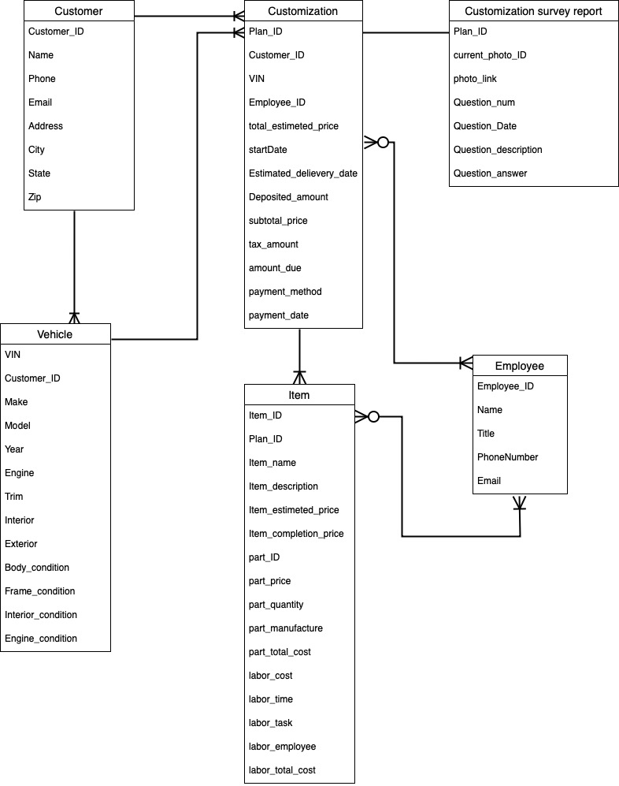

# FIG.1. ER-MODEL for Joe’s Chop

### 3.1.2 Logical Data Model (In Normalized form)

In this section we are representing the information of the logical data model, which is the outcome after the third normalization form.

# FIG.2. Logical Data Model for Joe’s Chop (3rd normalized form)

|  |  |
| --- | --- |
| **Table name** | **Description** |
| Customer | This table describes the attributes of the customer including the Name, Phone, Email, Address, City, State, and Zip.  This Table is also directly related to the customization detail table. |
| Customization_detail | This table describes the attribute of customization detail including the Plan ID, Customer ID, VIN, and Employee ID.  This table is directly related to the Vehicle table, employee table, customer table, and customization plan table. |
| Employee | This table describes the attributes of an employee including the employee ID, Name, Phone Number, and Email. This table is directly related to the customization detail, and item table. |
| Vehicle | This table describes the attributes of the vehicle including the VIN,Make, Model, Engine, Trim, Interior, Exterior, Body Condition, Frame Condition, Interior Condition, and Engine Condition. This table is directly related to the customer and customization detail table. |
| Customization_plan | This table describes the attribute of the customization plan including the Plan ID, Total estimated price, Deposited amount, start Date, Estimated delivery date, subtotal price, tax amount, amount due, payment method, payment date, current photo ID, and photo link. This table is directly related to the customization plan and the Questionnaire table. |
| Questionnaire | This table describes the attributes of the questionnaire including the Plan ID, Question num, Question date, Question description, and question answer. This table is directly related to the customization plan table. |
| Part | This table describes the attributes of the part including the part ID, part price, part manufacture. This table is directly related to the part detail table. |
| Item | This table describes the attributes of the Item including the Item ID, Item name, Item description, Item estimated price, Item completion estimation, Item actual parts cost, and Item actual labor cost. This table is directly related to the part detail table and the Labor detail table. |
| Labor | This table describes the attributes of labor including the Labor ID, labor cost, and labor description. This table is directly related to the labor detail table. |
| Part_Detail | This table describes the attributes of part detail including the part ID, Item ID, part quantity, and part total cost. This table is directly related to the part table and item table. |
| Labor_detail | This table describes the attributes of labor detail including the Labor ID, Item ID, labor employee, labor time and labor total cost. This table is directly related to the item table and labor table. |

## 3.2 System Architecture with tools and techniques

# FIG.3. Joe’s Chop system architecture

**Hardware:**Since our database is stored within the AWS cloud system and our server is executed locally through our computer or laptop, there's no need to worry about any aspect of hardware.

**Software and tools and techniques:**

There are certain tools and software you need to run the application. The Joe's Chop database system architecture acquires a variety of aspects of the implementation in order to make it work. First, we use the amazon web service system (AWS) to create our cloud database through the Ec2 instance in order to connect the local MySQL workbench to the cloud database. Second, We use the python and Flask framework to write the back end of our website, the back end code also directly connected to the amazon RDS. The connection between the website and MySQL workbench is considered similar. By inserting the endpoint port url, user name, user password to create a new connection for the cloud database to connect the MySQL workbench. By inserting the endpoint port url, user name, user password, database name, database bucket, and database region allows the cloud database to connect with the back-end code written with python in the main app.py file. Last, For the Front end website, we implement the HTML, CSS, Bootstraps, and NicePage for a quick solid website front-end creation. The Tools and techniques we implement during this project include the software aspect and hardware aspect. One of the techniques related to software is we create different pages of the website simultaneously, and we share our code through github to integrate our working website everyday. Hence, largely increase the efficiency of the website development and team communication which also greatly reduces the chances of misinterpreting teammate's ideas or opinions.

## 3.4 DDL statement summary

* We have used the CREATE DDL statement to create a database named “JoeDB” and tables according to the 3rd normalization form. There is a glimpse of CREATE function from joeDBscript.sql file:

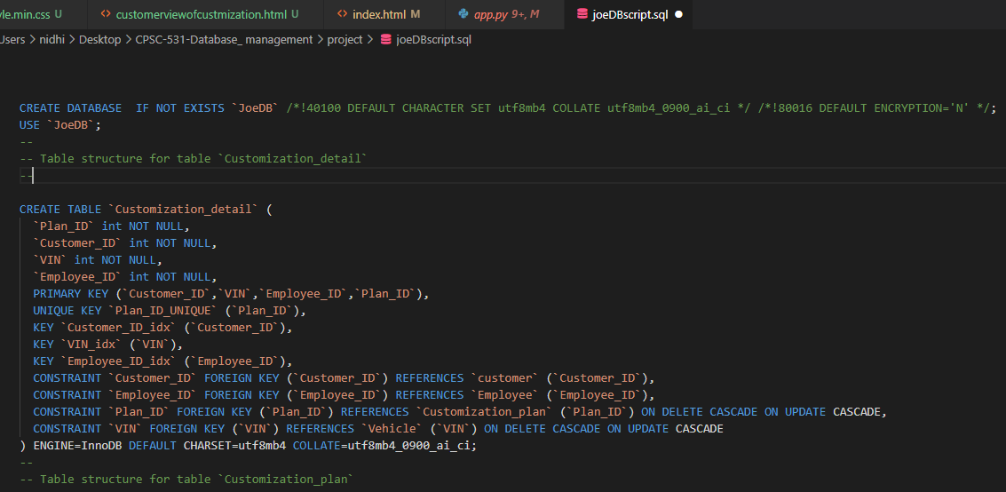

* We have also used ALTER STATEMENT WITH ADD Column command to add columns while creating application as per necessity. We also have used ALTER STATEMENT with RENAME command to change the table name as per application necessity after creating a table in a database named JoeDB. Here showing a glimpse of those script from joeDBscript:

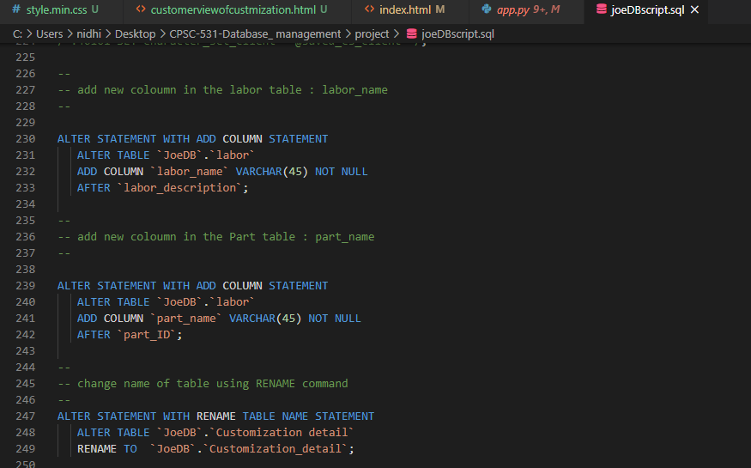

## 3.5 Function requirement Design

In this section, we are representing the forms and reports that will be implemented for web application functionality for Joe’s chop shop. Also, we are going to represent the test input cases and expect result details for forms for testing and analyzing the results of web application functionality.

### 3.5.1 **Implement a new customization pla**n

This function will be performed by Joe’s chop employee when customers visit the shop to modify their vehicle. In this function, the employee should gather information related to the new customization plan for the vehicle that customers bring to shop. In the web application, this functionality will be available under the employee web page after login. This function will create a new customization plan when an employee hits the submit button and create a new data entry in the related tables in JoeDB database.

1. **Login of employee to access the initial customization form.**

* Here we are showing the login page for employees.

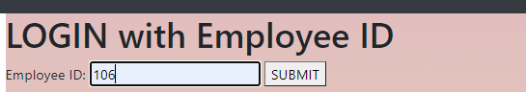

* In this page, the employee will be able to login in the system to use other functionality by providing an employee id number and clicking the submit button. When an employee will submit the button after entering the employee id, the system will verify the employee id number.
* Here showing the system process for searching the employee id for verification:

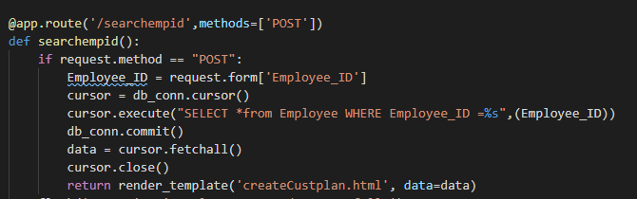

* After the verification, the employee can access the new implementation customization form which will be the next step to generate a customization plan for the customer who is in the shop with his/her vehicle.

1. **Fill out the initial customization form and submit the form**

* The employee will fill out the form with customer, customer’s vehicle information and will select the some customization plan attributes to fill out to start the customization process for the customer.
* Here we are presenting the input screen of the initial customization form with input entries.

# FIG.4. Joe’s Chop Customization plan Creation Form

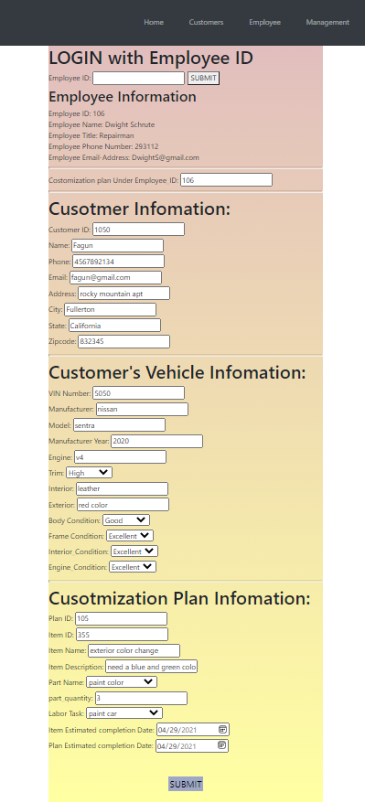

* After entering the information the employee will submit the data entries by clicking on the submit button.
* The Clicking on submit button will trigger the system function that processes the query on the JoeDB database through DML commands. Here we are showing the glimpse of that query function and explaining the process of the system to run that function by connecting with JoeDB database.
* **The glimpse of functionality code with DML commands and explanation:**
* **Note: This code is from the file name “ app.py” which is mentioned in the appendix below.**

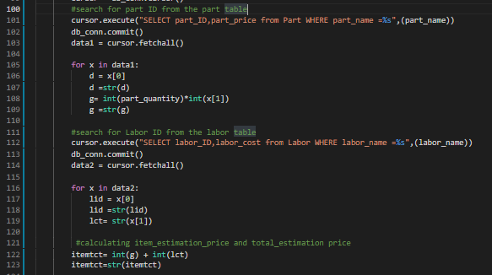

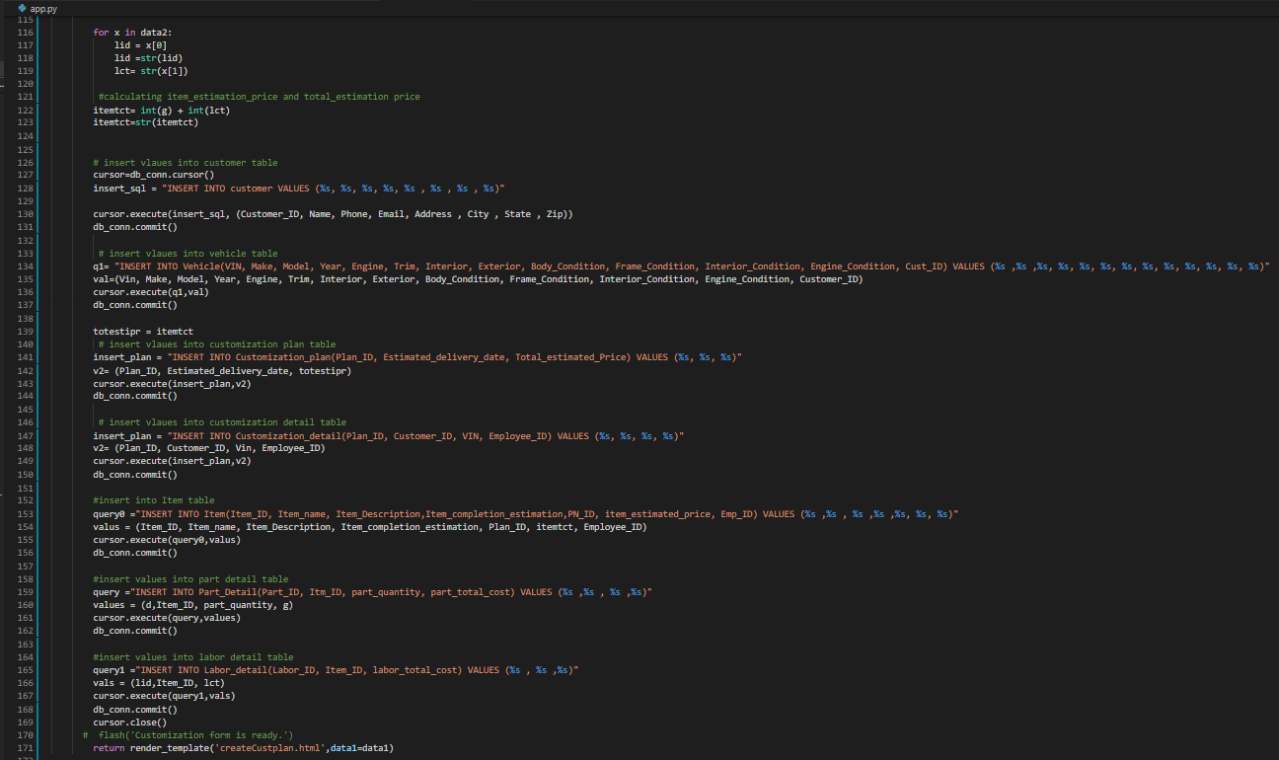

**Steps of the system function who runs the query on a database named JoeDB for this functionality.**

* First the system will connect with the database and with the SELECT command it will ask the Part_id, part_price from part table by selecting part_name and labor_id, labor_cost from labor table by selecting labor name.
* The system will calculate estimated price for part and labor with above collected values and find total estimated price = total_part_cost + total_labor_cost
* The system query will start to create a new entry by INSERT command in parent tables such as customer, vehicle, customization_plan.
* After creating a new entry on those tables, the system will start to create new entries using the INSERT command in child tables such as customization_detail, item table (parent of part_detail and labor_detail) and then part_detail and labor_detail tables.
* At the end of this function system will confirm the initial customization plan is ready.
* Here instead of showing that message window, we are showing the glimpse of one table named as **“customer”** data entry through the MySQL workbench tool to show the output of the function.

**Note: the blue line in the following figures are the new data entry.**

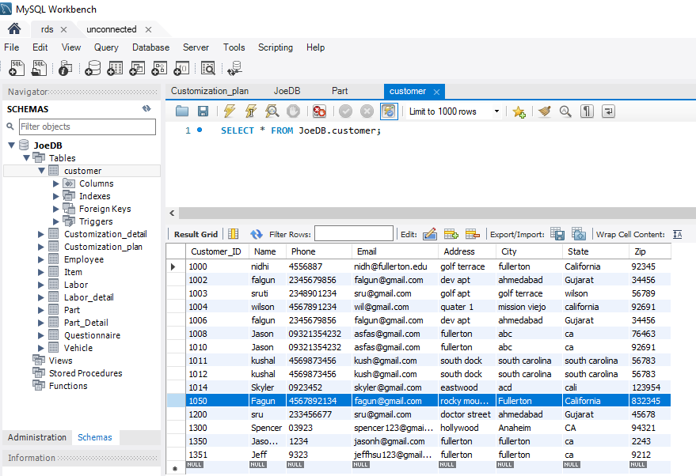

* In application, the employee or customer can view this new data entry through functions named “ **Monitoring vehicle customization progress” and “customization plan progress processing”.**

### 3.5.2 customization plan progress processing

This function is used by employees of Joe’s chop shop. If employees would like to see the detail of those customization plans that they are responsible for, then they can use this function. Moreover, if the employees would like to update any information in customization plans under their responsibility, then they use this function, This functionality in the website available under employee page. No employee can look into each other’s plan details. This functionality can be used as many times as per business needs. Some information related customization plans will be available on screen with no access to update some information such as plan number, customer and vehicle information.

1. **Login function for employee and search the customization plan detail with providing planid number or searching all customization plan that employee is responsible for.**

* Here we are showing the login page and the searching criteria options for the employee to see the customization plan that employee would like to look into and update it.

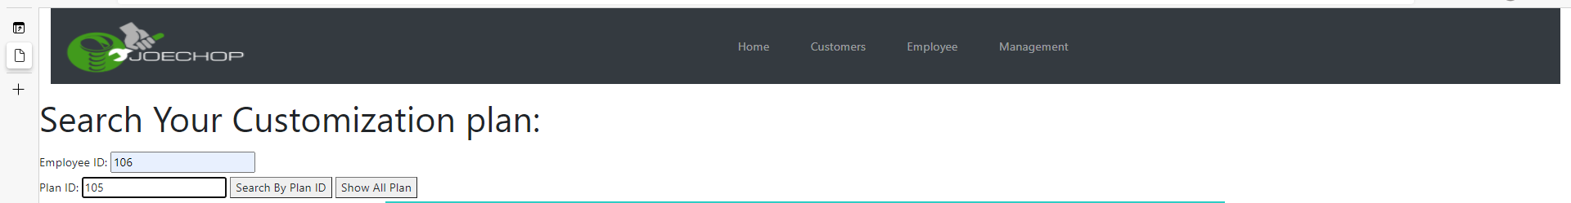

* So, employees will login by entering the employee id number and system verify employee login information. After verification, the employee can search all customization plan details by clicking on the “show All Plan” button or the employee can search the plan by providing a plan id number and clicking on the “Search By Plan ID” button as shown in above figure.
* Here we are representing the process code for searching plan detail .
* 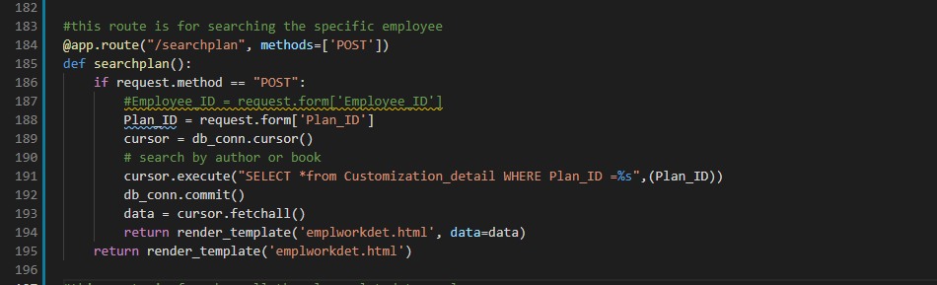
* The above query code will search the customization plan detail and show the following output window. 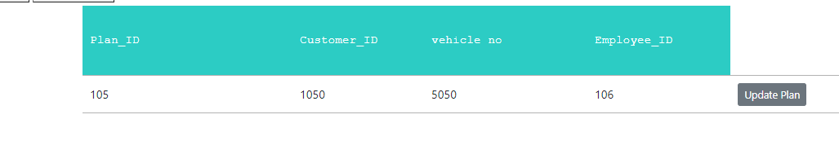
* In the output window, the employee can see the customer id and vehicle number which is connected with the plan id 105. This output will provide the employee with an update plan option to enter any new information that employee would like to add in that particular customization plan.
* Once the employee clicks on the “Update Plan” button, the system will provide the employee a new form with some printed information that has been entered before this update process.

1. **Update the customization plan as needed for the business with customers.**

* Here, we are showing the customization update form and the input values that the employee will fill out for completing the business of customization for that customer.

# FIG.5. Joe’s Chop Customization progress report and form

* After entering the information that the employee would like to update, the employee will click on the update button and that will call the system to process the update by calling the function. Here we are representing the glimpse of the function code with the following explanation.
* 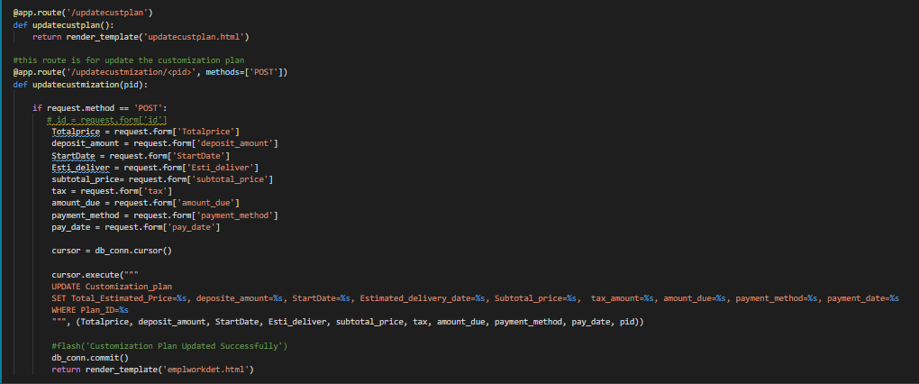**The glimpse of functionality code with DML commands and explanation:**
* **Steps of the system function who runs the query on a database named JoeDB for this functionality.**
* The above query code will update the customization plan, and show the following output window.
* At the end of this function system will confirm the update of the customization plan is ready.
* Here instead of showing that message window, we are showing the glimpse of one table named as **“Customization_plan”** data entry through the MySQL workbench tool to show the output of the function.

**Note: the blue line in the following figures are the new data entry**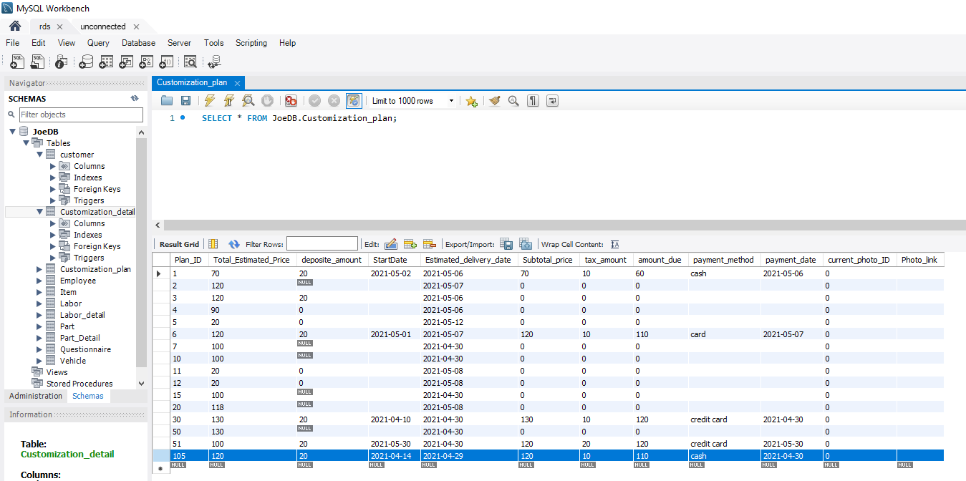

* In application, the employee or customer can view this new data entry through functions named “ **Monitoring vehicle customization progress” and “customization plan progress processing”.**

### 3.5.3 Joe’s Chop employee relation with Joe's Chop

This functionality will be executed by the manager or supervisor to see the relationship of all employees with Joe’s chop shop. This functionality also allows managers to create a new employee relation. Also allow the manager to edit employee relations with joe’s chop shop. And also allow to remove the employee relation if the employee will no longer work for Joe’s chop.

Here we are showing the relationship management functionality into three sub functionality.

1. **View all employee relationship or just one employee relation with shop**

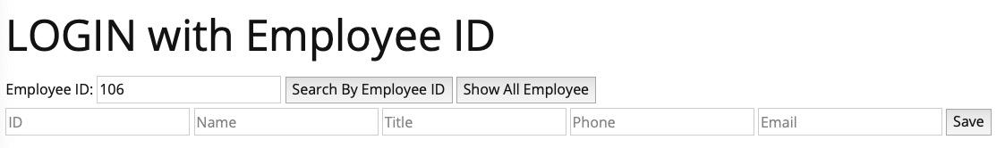The manager can search the employee with a specific employee ID. The input will be employee ID: 106 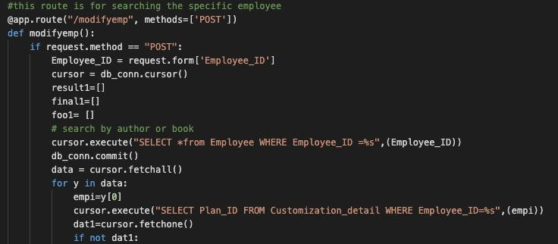

The above query code will search the specific employe information using SELECT DML command with Plan_id from other table, and show the following output window.

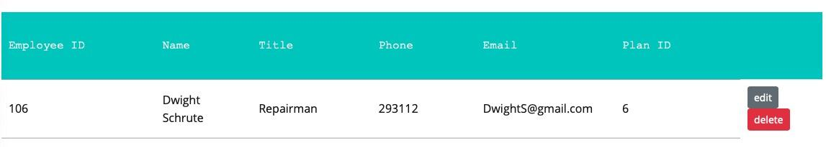The output will be the information for Employee ID 106 including the employee ID, Name, Title, Phone, Email, Plan ID.

* The manager can search all the employee information by clicking the show all employees.

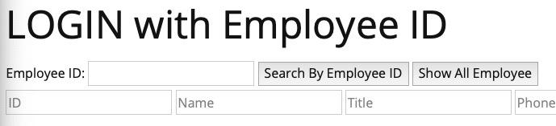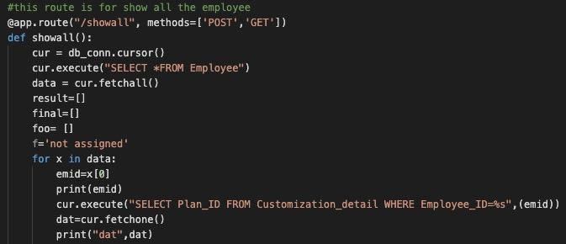

The above query code will search all the employee information using SELECT DML command with employee id, and show the following output window.

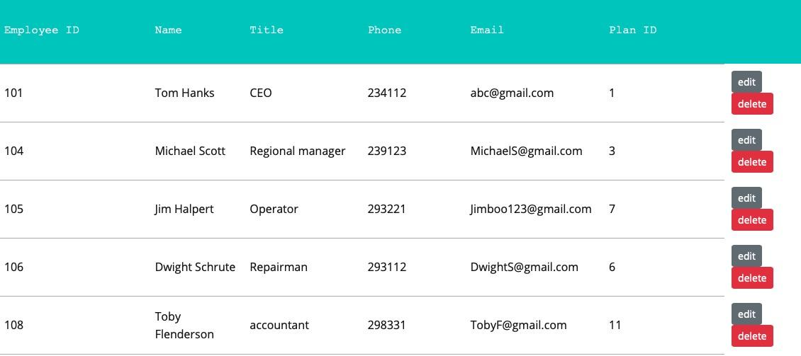

# FIG.6. Joe’s Chop Employee management report

The output will be the information for all the Employee information including the employee ID, Name, Title, Phone, Email, Plan ID.

1. **Create a new employee relation with Joe’s chop system**

The manager can add a new employee by inserting the employee ID, name, title, phone, and email. This will consider an input. 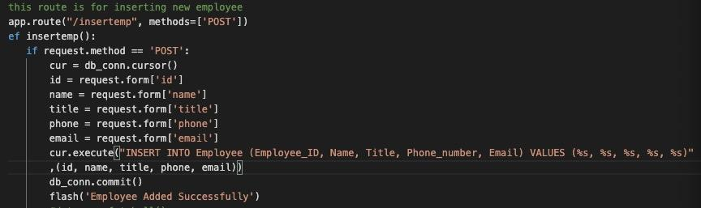

The above query code will insert the new employee information including the employee_ID, Name, Title, Phone_number, Email into the Employee table.

The output will be a new employee with detailed information added into the database.

1. **Edit the specific employee information currently within the database.** 
   1. When the manager clicks the edit button, the manager can edit the information of the specific employee. This will be referenced from 3.5.6
2. **Delete the specific employee information currently within the database.** 
   1. When the manager clicks the delete button, the manager can delete everything about the specific employee. Also, the system will make sure the plan ID for the specific employee ID is currently 0 before deleting it.

When the manager deletes employee information with employee ID 114.

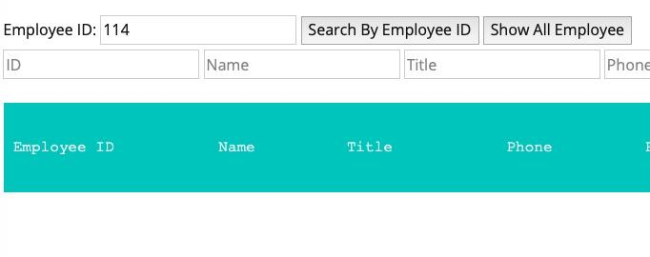output: there will be no more employee ID 114 information exists in the database when searching the employee by ID.

### 3.5.4 Manage employee relation with Joe's Chop

1. **Search the plan by plan ID**
   1. When the manager wants to search for the specific plan, the manager can search with a specific plan ID. This is considered the input.

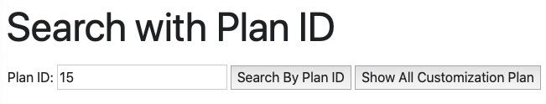

The manager can search for plan ID 15 to inspect the information of plan ID 15.

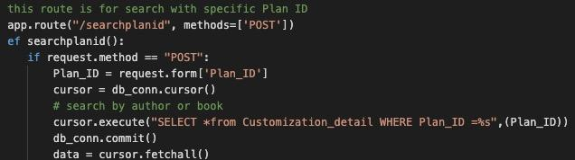

The above query code will select the specific plan ID in the customization detail 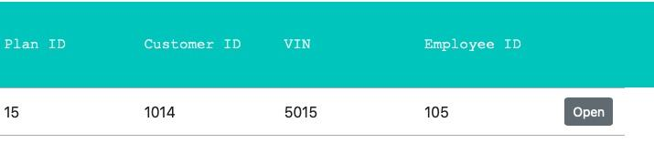table to show the plan ID information.

output: after searching by the plan ID, the website will display the information of the specific plan ID, including the plan ID, customer ID, VIN, and Employee ID.

1. **Show All the customization plan currently within the database.**
   1. The employee can show all the current plan ID by clicking the show all customization plan button.



The input is considered by clicking the show all customization plan.

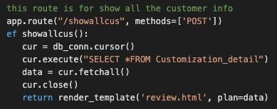

The above query code will select every information from the customization detail.

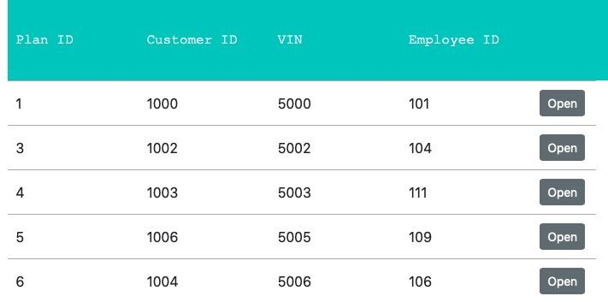

output: after clicking show all customization plans, it will display all the information within the customization detail table including the plan ID, customer ID, VIN, and Employee ID.

1. **Open the specific plan to edit the plan details information.** 
   1. The Manager can change the information of the customization plan details by clicking the open button for the specific plan ID. If the manager wants to change the 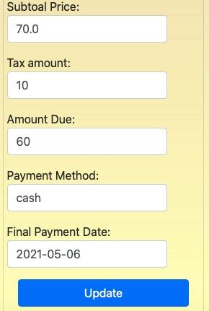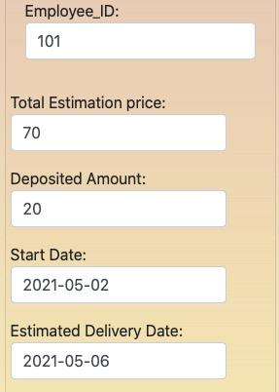information of plan ID 1, just click the open button.

The above is the customization plan details page with plan ID: 1, this is considered the input, the manager can change the employee ID 101 to another employee ID, so that the plan ID 1 can be in charge of the other employee ID. The manager can also update the information of total estimation price, deposited amount, start date, estimated delivery date, subtotal price, tax amount, amount due, payment method, and final payment date.

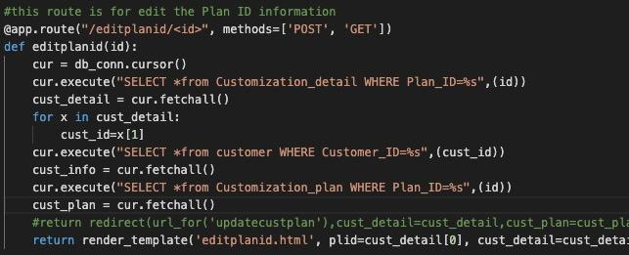

The above query will select the specific plan ID from the customization detail table. when the manager clicks the update. the update will be run with another code.

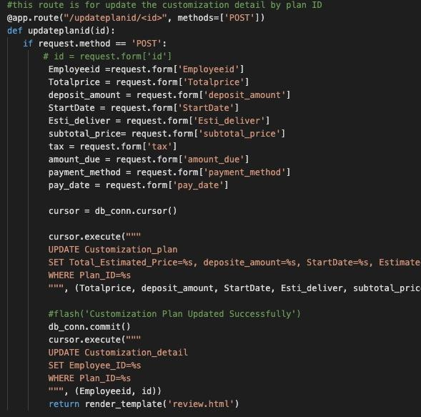

The above query will select all the information in the form including the new employee id, total price, deposit amount, start date, estimate delivery date, subtotal price, tax, amount due, payment method, and pay date from the webpage. After that, it will update the customization plan table by setting those attributes with a new value.

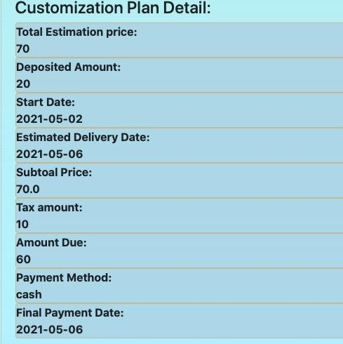

When login with the customer ID in the car modification page within the customer page, the result will be displayed down below as the output.

### 3.5.5 Monitoring vehicle customization progress

This functionality allows customers to view the customization progress of their vehicle. No customer can see another customer’s customization plan. This functionality just allows the customer to view the plan details with all billing information and initial plan details with vehicle condition before the vehicle modification has been processed. The customer can also see day to day updates when employees update the information related to that customization plan. Also, customers can access employee contact information to communicate to discuss the customization plan details. However, the customer can not edit any information by himself.

* **This functionality will have two sub functions as follows.**

1. **Login of customer to view customization plan details.**

* Here we are showing the login page for customers.

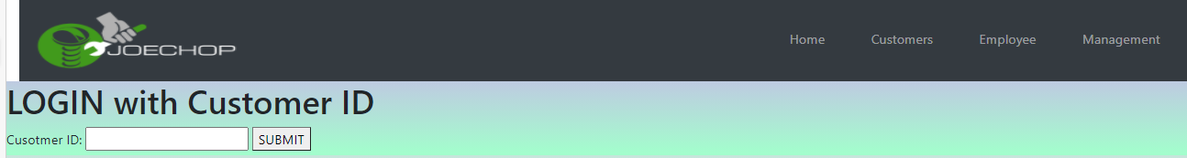

* In this page, the customer will be able to login in the system to use other functionality by providing the customer id number and clicking the submit button.
* When a customer clicks on the submit button the system will verify the customer validation and provide the details of customization plan in a report that customer would like to see.
* Here showing the system process for collecting all customization plan information 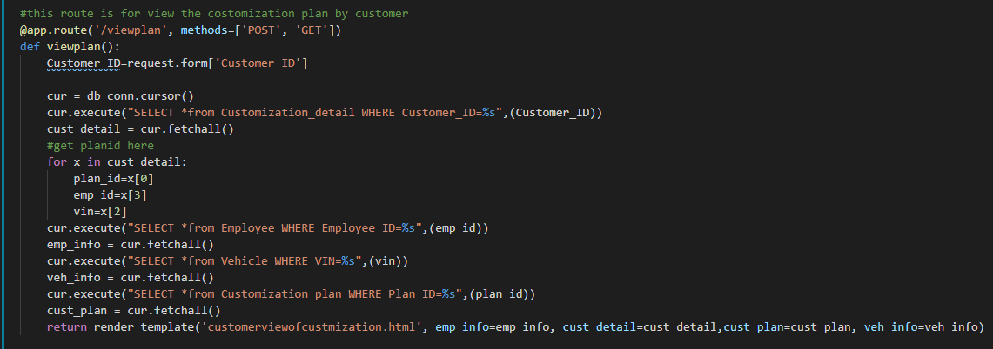for that customer.
* Using SELECT DML command, the system will collect the information from the Cutomization_detail table, employee table, vehicle tables, and customization plan tables.
* The system will arrange necessary information into one report and show the report to the customer as output of this function query.

1. **View customization plan report.**

Here we are representing the report for a customer whose customization plan has been created under section 3.5.1. That means the customer id will be 1050.

# FIG.7. Joe’s Chop Customization plan report for Customer View

### 3.5.6 personal profile summary and modification

This functionality can be accessed by the customer, employee and management to edit the profile information. All users of this functionality will have to login first which call system to do the login verification process. After the login, the customer and employee can see their personal details information and can edit information and click on the update button. Only management can access all employee personal information, no employee or customer can see other’s personal information. In all cases, the user can not modify the id numbers.

1. **customer: view and modify personal information.**

* the customer will login with their customer id and system will verify the login information. After the verification, the system will show customer’s personal information with update button, The output window is as follows:

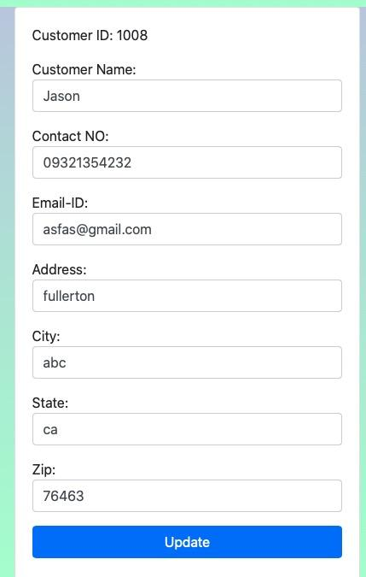

* Customer will edit the needed change and click on the update button. This clicking process will call system function to update as following:

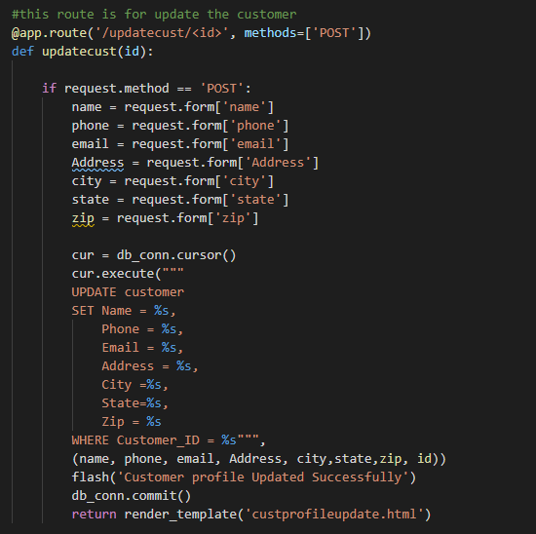

* The system will update the modified information into the table of database using the UPDATE DML command as shown above figure
* The updated information can be viewed by calling the profile summary and modified functionality.

1. **Employee and management: view and modify personal information.**

* the employee will login with their employee id and system will verify the login information. After the verification, the system will show the employee's personal information with an update button. The management will select a particular employee to update that employee’s personal information and see the detail information page with the update button. The output window is as follows:

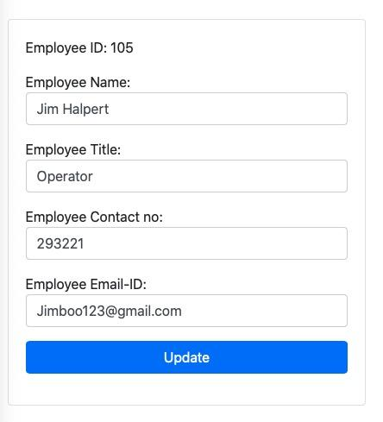

* Employees or management will edit the needed change and click on the update button. This clicking process will call system function to update as following:

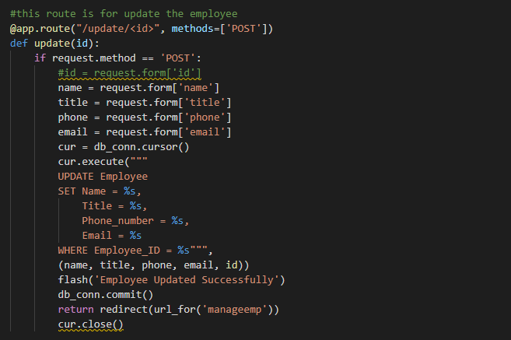

* The system will update the modified information into the table of the database using the UPDATE DML command as shown above figure.
* The updated information can be viewed by calling the profile summary and modified functionality.

## **3.6** System installation and implementation

### 3.6.1 What do you need to run the application?

* IDE to open the files (Visual Studio) or command prompt to run the application file.
* python interpreter
* require python modules including Flask, Flask-MySQLdb, Flask-SQLAlchemy, mysql, mysql-connector, mysqlclient, PyMySQL, SQLAlchemy, flash, aws-credentials
* Browser including Chrome, Safari, and Firefox.

### 3.6.2 User-guide

* **User guide to run application in windows operating system**
* Either open the source code in editor tool or open the folder in command prompt
* The name of the folder is “Joe's Chop group DB-8 sourcecode.zip”
* There’s a python file named app.py, run the code by typing “python3 app.py” in the terminal.
* After execute the app.py file, the ip address will show up in the prompt (terminal for mac)
* Copy the provided ip address into the web browser and run the application
* For window users, the last line of code for the host should be ‘127.0.0.0’, port = 80. But for Mac OS users, change the last line of code into ‘0.0.0.0’, port = 80.

Note:to install required modules to run the application: Flask, Flask-MySQLdb, Flask-SQLAlchemy, mysql, mysql-connector, mysqlclient, PyMySQL, SQLAlchemy, flash, aws-credentials.

Type pip3 list in the command line to check whether the computer already has those packages or not.

# Chapter 4: Result and Discussion

Joe's main motivation for this project was to build a system that provides him with the tools to efficiently and profitably run his business, while attracting more customers to his business. The DB-8 team supports Joe in his dream by providing a well-designed SQL based RDBMS and a robust web application with all the functionality Joe needs to flourish in his business.

Joe's chop is in the business of providing the best modifications of vehicles to customers as they desire, and within their budget. In that case, the DB-8 team provides functionality entitled **"Implementing a new customization plan"(ref:section 3.5.1)** and **"customization plan progress processing,"(ref:section 3.5.2)** which is integrated with some standard forms for managing all customization plans provided by Joe's Chop Shop to their customers. These are the most important features for the creation of information to analyze business performance as well as other factors by collecting data on customers, vehicles, and customization tasks associated with the modification process. For example, these functions allow Joe's chop shop to collect information about its customers, in particular their address and zip code. By analyzing this information, Joe's chop shop can identify the marketing zip codes where the majority of their customers live to better promote their business.

As well, Joe can strategize his business by gathering details about customization plans such as what parts were used, the estimated cost per task item under the modification of a vehicle, vehicle features and manufacturing data, and how much customers are willing to spend on modification. The information will be useful to him in planning his resources, for example managing suppliers for the parts Joe's chop used for modification, and also help him compensate for the profit margin and investment margin behind his resources, and provide an estimate of the cost for future modification of the same type of vehicle. Additionally, Joe can promote their services by identifying common modification tasks specific to particular vehicle types, and by discovering how much their customers are willing to pay for modifications. Moreover, Joe can analyze his commitment to his business by determining the modification plan estimation date and actual completion date with regard to customer satisfaction, as well as find out how committed his employees are to their work and the company standards.

Additionally, DB-8 has provided the functionality of **"Joe's chop employee workload management"(ref: section 3.5.4)** in order to gauge employee commitment to their work and to business growth. The information provided by this feature helps Joe and his management team manage their employees' workloads and motivate them to modify their vehicles for greater profits.

In addition to employee workload management, DB-8's module of **"Manage employee relations with Joe's chop"(ref:section 3.5.3)** also provides support to the HR department of Joe's chop in recruiting, hiring, and other activities needed to attract and retain employees. Also the functionality **“ personal profile summary and modification” (ref:section 3.5.6)** helps the HR department to manage employee personal information for better employee management.

The **“ Monitoring vehicle customization progress”(ref:section 3.5.5)** function of this application provides a **customization report(FIG.7.)** to customers to analyze the modification details of their vehicle. This report can help customers to find the difference between the vehicle condition before and after the modification. In addition, this report can also identify in detail how much money the customer spent or has to spend behind the modification task they requested. It allows customers to reference the information of JoE's chop commitment for future modifications by comparing estimated completion dates and actual completion dates towards satisfying the customer's desire.

# Chapter 5: Conclusion

## 5.1 Significance of the project:

The significance of this project is to build a well-designed database structure and website application that can increase productivity and profit by keeping connections with customers through the new technology. For every page of the information, whenever the user submits the information of the customer, the employee, customization plan detail, and vehicle. All the information will be stored within the SQL database, which by following the logical data model is able to construct an organized database structure for solid future development. With the solid and organized data structure, the engineer is able to find the hidden correlation and pattern betweens different tables for future data analysis. Last, By normalizing the data model from 1NF to 3NF to remove the data redundancy will produce better outcomes of the data.

## 5.2 Lesson Learned:

From this database project, we learn how to gather the requirements from the customers and to build the database structure with normalization techniques. We learn that having a well-rounded logical data model is a crucial point when creating the database in MySQL since we can observe which attribute should consider a primary key, foreign key, or unique key. We learn how to create a relational database under the AWS cloud platform. We also learn how to connect with AWS RDS through a python web application using the Flask framework. Last, we learn to use MySQL DDL commands using flask to update the back-end database to provide better productivity of the application.

## 5.3 Future design improvement:

For a future website, the improvement includes three main aspects. The website application design improvement, The Database design improvements, and the system architecture improvement.

**5.3.1 Website application design improvement:**

There are three main topics we need to improve for our website, including the implementation of a single login page for each website user to access information from the database. The level of communication can be increased by showing everyday progress to customers with pictures and asking questions when needed. Improve User Interface design.

**5.3.2 Database design improvements:**

There are three main topics we need to improve for our website, including optimizing the database structure to store singing information after introducing the signing page and making sure the database remains normalized up until a third normalization level. For our daily progress on the customization of a vehicle will be depicted through photos, therefore, for managing these photos data, we will require a NoSQL database. In the near future, we may use hybrid models of the database for this application. To optimize the database design, to make use of the indexes, cross joints, and other database management techniques to handle big data.

**5.3.3 System Architecture improvement:**

We are currently accessing AWS RDS over a public connection. For the future releases will instead adopt the amazon web services EC2 instance and a domain name, which will enhance the security and safety of the JoeDB database and provide users with access.

## 5.4 Potential Use:

Some of the potential uses of this project include various aspects. To facilitate the operation of the Joe Chop Garage Shop, a relational database is being implemented to store all the data that is required. Additionally, the website is used to provide users the opportunity to review the information about their customized vehicle. This project could be useful for other similar businesses or garage shops that focus solely on repairing vehicles. This project could also be useful for the power car wash company that focuses on both interior and exterior cleaning.

# Reference

<https://youtu.be/7Gym2XVcA5A>

<https://youtu.be/WmGgxTpGs_8>

<https://www.youtube.com/watch?v=xzCgeRxSzy4>

# Appendices

With this document, we are attaching some code files for a clear view of code of the web application for showing DDL and DML commands with SQL Query. The folder that contains all this files named as “Joe's Chop group DB-8 sourcecode.zip”

The Files names and its explanation under “Joe's Chop group DB-8 sourcecode.zip” folder as following:

1. joeDBscript.sql :

This file contains the DDL commands that we use to create database JoeDB and its tables.

1. app.py:

This file contains the code to run the web application functionality with performing the query scripts with DML commands.

1. rds_db.py:

This file contains the code to connect the web application with our database which runs on AWS RDS platform.